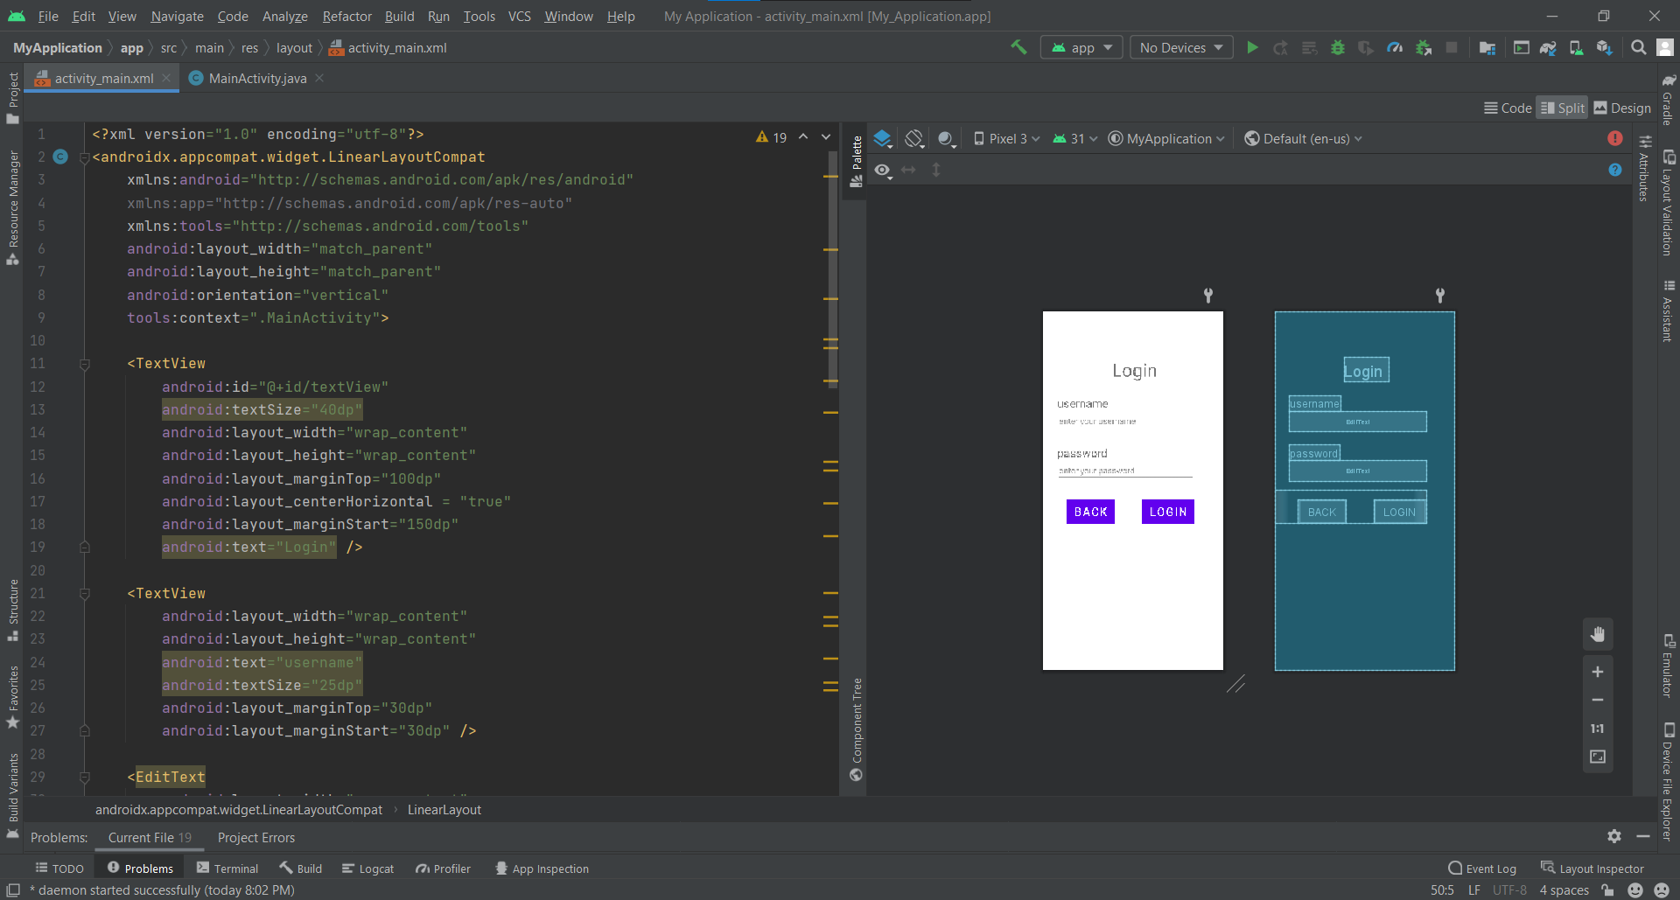

<?xml version="1.0" encoding="utf-8"?>  
<androidx.appcompat.widget.LinearLayoutCompat  
 xmlns:android="http://schemas.android.com/apk/res/android"  
 xmlns:app="http://schemas.android.com/apk/res-auto"  
 xmlns:tools="http://schemas.android.com/tools"  
 android:layout_width="match_parent"  
 android:layout_height="match_parent"  
 android:orientation="vertical"  
 tools:context=".MainActivity">  
  
 <TextView  
 android:id="@+id/textView"  
 android:textSize="40dp"  
 android:layout_width="wrap_content"  
 android:layout_height="wrap_content"  
 android:layout_marginTop="100dp"  
 android:layout_centerHorizontal = "true"  
 android:layout_marginStart="150dp"  
 android:text="Login" />  
  
 <TextView  
 android:layout_width="wrap_content"  
 android:layout_height="wrap_content"  
 android:text="username"  
 android:textSize="25dp"  
 android:layout_marginTop="30dp"  
 android:layout_marginStart="30dp" />  
  
 <EditText  
 android:layout_width="wrap_content"  
 android:layout_height="wrap_content"  
 android:layout_marginStart="30dp"  
 android:hint="enter your username"  
 android:width="300dp"/>  
  
 <TextView  
 android:layout_width="wrap_content"  
 android:layout_height="wrap_content"  
 android:text="password"  
 android:textSize="25dp"  
 android:layout_marginTop="30dp"  
 android:layout_marginStart="30dp" />  
  
 <EditText  
 android:layout_width="wrap_content"  
 android:layout_height="wrap_content"  
 android:layout_marginStart="30dp"  
 android:hint="enter your password"  
 android:width="300dp"/>  
 <LinearLayout  
 android:layout_marginTop="20dp"  
 android:layout_width="wrap_content"  
 android:layout_height="wrap_content"  
 android:orientation="horizontal">  
 <Button  
 android:layout_width="wrap_content"  
 android:layout_height="wrap_content"  
 android:text="back"  
 android:textSize="25dp"  
 android:background="#F44336"  
 android:layout_marginTop="20dp"  
 android:layout_marginStart="50dp"/>  
 <Button  
 android:layout_width="wrap_content"  
 android:layout_height="wrap_content"  
 android:text="login"  
 android:textSize="25dp"  
 android:background="#009688"  
 android:layout_marginTop="20dp"  
 android:layout_marginStart="60dp" />  
  
  
 </LinearLayout>  
</androidx.appcompat.widget.LinearLayoutCompat>